ARTICLE TITLE WRITTEN IN A MAXIMUM OF 20 WORDS, WITHOUT MENTIONING THE RESEARCH LOCATION, WRITTEN IN INDONESIAN USING TIMES NEW ROMAN 12-POINT BOLD FONT

Author¹), Author²) (Times New Roman 10-Point Bold Font; Authors’ Names Must Not Be Abbreviated)

¹Faculty Name, University Name, Complete Address (Author 1)
²Faculty Name, University Name, Complete Address (Author 2)

Article Info |  | ABSTRAK (10 pt)
Article history:  Received: mm dd yy  Revised: mm dd yy  Accepted: mm dd yy |  | Abstrak ditulis dalam satu paragraf utuh dan merupakan ringkasan lengkap yang mencerminkan keseluruhan isi artikel secara singkat, jelas, padat, dan informatif. Isi abstrak harus memuat secara berurutan latar belakang atau permasalahan penelitian, tujuan penelitian, metode penelitian yang meliputi desain penelitian, lokasi penelitian, jumlah sampel atau responden, teknik pengumpulan data, instrumen penelitian, serta metode analisis data yang digunakan, kemudian hasil penelitian utama yang disajikan secara spesifik dan kuantitatif apabila memungkinkan, serta diakhiri dengan kesimpulan yang menjawab tujuan penelitian dan menunjukkan implikasi utama hasil penelitian. Abstrak tidak diperkenankan memuat sitasi atau acuan referensi, kutipan langsung, tabel, gambar, rumus matematika, simbol khusus, maupun catatan kaki. Penggunaan singkatan sebaiknya dihindari. Panjang abstrak maksimal 200 kata, diketik menggunakan huruf Times New Roman ukuran 10 pt, spasi tunggal, dan rata kiri-kanan. Cantumkan 3–5 kata kunci yang disusun secara alfabetis, dan dipisahkan dengan tanda titik koma.
Keywords:
First Keyword;
Second Keyword;
Third Keyword;
Fourth Keyword;
Fifth Keyword;

Corresponding Author:
Full Name

Faculty, University, address of university.

Email: abc@gmail.com
ABSTRACT
Abstract must be written as a single, complete paragraph and should provide a comprehensive summary that reflects the entire content of the article in a concise, clear, and informative manner. The abstract should include, in sequence, the background or research problem, the research objective, the research methods, including the study design, study setting, sample size or respondents, data collection techniques, research instruments, and data analysis methods, followed by the main research findings presented as specifically and quantitatively as possible, and conclude with a statement that addresses the research objective and highlights the main implications of the findings. The abstract must not contain citations or references, direct quotations, tables, figures, mathematical formulas, special symbols, or footnotes. The use of abbreviations should be avoided whenever possible. The abstract should not exceed 200 words and must be typed in Times New Roman 10-point font, single-spaced, and justified. Authors should provide 3–5 keywords arranged in alphabetical order and separated by semicolons.

This is an open access article under the Creative Commons Attribution 4.0 International License.

INTRODUCTION
The INTRODUCTION heading should be typed in uppercase letters using Times New Roman, 12-point, bold. This section should contain the background of the study, highlighting the problem addressed, the urgency and rationale of the research, as well as the research problem or hypothesis. At the end of the introduction, authors may include the objectives of the article, literature review, proposed problem-solving approach, research objectives, and hypothesis development.
Author Note: The manuscript should be between 3,000–4,000 words or a maximum of 15 pages, including references and notes. All submitted manuscripts will be screened for plagiarism. Articles must be prepared using Microsoft Word, typed in Times New Roman 12-point font, single-spaced, on A4-sized paper with margins of 3 cm (left, top, right, and bottom). The maximum manuscript length is 15 pages.
Authors may submit and register their manuscripts through the Online Journal System (OJS) at:
https://ejournal.lenterailmunusantara.com/index.php/index/id/login

METHODS
The METHODS heading should be typed in uppercase letters using Times New Roman, 12-point, bold. This section should describe the research design, population, sample/informants, time and place of study, variables, instruments, research procedures, data collection methods, data processing, and data analysis techniques. Variable measurements should be presented in flowing paragraphs and should not use numbering. The text should be written in Times New Roman, 12-point, normal font, single-spaced.

RESULTS
The RESULTS heading should be typed in uppercase letters using Times New Roman, 12-point, bold. This section should present the research findings comprehensively and in accordance with the research objectives. Results may be supplemented with tables, graphs, figures, or charts. All tables and figures must be numbered and provided with titles. Data analysis results should be interpreted according to the findings obtained. The text should be written in Times New Roman, 12-point, normal font, single-spaced.

DISCUSSION
The DISCUSSION heading should be typed in uppercase letters using Times New Roman, 12-point, bold. This section should explain the findings and relate them to relevant references based on theories, previous studies, and empirical evidence identified during the research. The text should be written in Times New Roman, 12-point, normal font, single-spaced.

CONCLUSION
The CONCLUSION heading should be typed in uppercase letters using Times New Roman, 12-point, bold. This section should provide a concise summary of the research findings and discussion, written in one or two paragraphs. The conclusion should answer the research questions or objectives and be written in essay form rather than as statistical statements. The text should be written in Times New Roman, 12-point, normal font, single-spaced.

ACKNOWLEDGMENTS (Optional)
The acknowledgment section is not intended for the authors themselves but for individuals or institutions that contributed to the research process, such as respondents, funding agencies, research assistants, or other supporting parties.

REFERENCES
The reference list must include all sources cited and used in the manuscript. References should primarily consist of relevant, recent, and high-quality scholarly sources. Authors are encouraged to use references published within the last five (5) years, with at least 80% originating from primary sources, such as scientific journal articles, conference proceedings, research reports, dissertations, theses, or other credible scholarly publications.
References must be prepared consistently according to the American Psychological Association (APA) 7th Edition citation style. All sources listed in the references must be cited in the manuscript, and all in-text citations must appear in the reference list. References should be arranged alphabetically by the surname of the first author without numbering.
To improve citation accuracy and consistency, authors are strongly encouraged to use reference management software such as Mendeley, Zotero, EndNote, RefWorks, or similar applications. The reference list should be formatted using Times New Roman, 12-point font, single spacing, following the APA 7th Edition guidelines.

Examples of Reference List Formatting
1. Books
Creswell, J. W., & Creswell, J. D. (2018). Research design: Qualitative, quantitative, and mixed methods approaches (5th ed.). Sage Publications.
Notoatmodjo, S. (2018). Health research methodology. Rineka Cipta.
2. Journal Articles
Putri, R. A., & Sari, D. P. (2023). The relationship between mothers’ knowledge and stunting prevention behavior among children under five. Jurnal Ilmiah Kesehatan, 12(2), 45–53. https://doi.org/10.xxxx/xxxx
Smith, J. A., & Brown, T. L. (2022). The relationship between health literacy and preventive behavior among rural communities. Journal of Public Health Research, 11(3), 210–220. https://doi.org/10.4081/jphr.2022.1234
Susanti, E., & Rahmawati, A. (2021). Risk factors for hypertension among coastal communities. Jurnal Keperawatan Indonesia, 24(1), 10–18.
3. Conference Proceedings
Rahman, A., & Putra, D. (2022). The effect of health education on clean and healthy living behavior among adolescents. In Proceedings of the International Conference on Public Health (pp. 120–128). Atlantis Press. https://doi.org/10.xxxx/icph.2022.001
4. Undergraduate Thesis, Master's Thesis, or Dissertation
Wulandari, F. (2021). The relationship between dietary patterns and the incidence of anemia among adolescent girls (Master’s thesis, University of Lampung).
5. Website or Webpage
World Health Organization. (2024). Anaemia. https://www.who.int/news-room/fact-sheets/detail/anaemia
Ministry of Health of the Republic of Indonesia. (2023). Indonesia health profile 2022. https://www.kemkes.go.id
6. Laws and Regulations
Ministry of Health of the Republic of Indonesia. (2023). Regulation of the Minister of Health of the Republic of Indonesia Number 2 of 2023 concerning the implementation of government regulations in the health sector. Ministry of Health of the Republic of Indonesia.
7. Organizational Reports
United Nations Children's Fund. (2023). The state of the world's children 2023. UNICEF. https://www.unicef.org
Note: Authors are responsible for ensuring the accuracy and completeness of all references cited in the manuscript. References that are not cited in the text or that do not conform to the APA 7th Edition format may result in the manuscript being returned for revision before the peer-review process can proceed.

Table Formatting Guidelines
Tables are used to present data systematically, enabling readers to understand research findings more easily. Each table must be numbered consecutively according to its first appearance in the manuscript and accompanied by a concise, clear, and informative title. Table numbers should be placed above the table using the format “Table 1.”, “Table 2.”, and so forth, followed by the table title on the next line. The table title should briefly describe the content of the table without requiring readers to consult the main text.
Each table should be self-explanatory, allowing readers to understand the information presented without referring to other sections of the manuscript. Any abbreviations used in a table should be defined in a table footnote if they have not been previously explained in the text. Tables should use both vertical and horizontal lines. If the table includes data sources or additional explanatory notes, this information should be provided below the table as a footnote. All tables must be cited and discussed within the Results section and should not be presented without interpretation or explanation.

Example of Table Formatting

Table 1.
Distribution of Respondents by Gender
Gender | Frequency (n) | Percentage (%)
Male | 10 | 20.0
Female | 40 | 80.0
Total | 50 | 100.0

Figure Formatting Guidelines
Figures are used to enhance the presentation of information, data, analysis results, conceptual frameworks, flowcharts, graphs, and supporting documentation relevant to the article. Each figure must be numbered consecutively according to its order of appearance in the manuscript using the format Figure 1., Figure 2., and so forth. The figure title should be placed below the figure and written in a concise, clear, and informative manner. Figures must be of high quality, easy to read, and directly relevant to the content of the article.
All figures should be referenced and explained within the text. Any symbols, abbreviations, or special notations used in a figure should be clearly defined either in the figure caption or within the manuscript text. If a figure is adapted or reproduced from another source, the original source must be acknowledged below the figure in accordance with APA 7th Edition citation guidelines.

Example of Figure Formatting
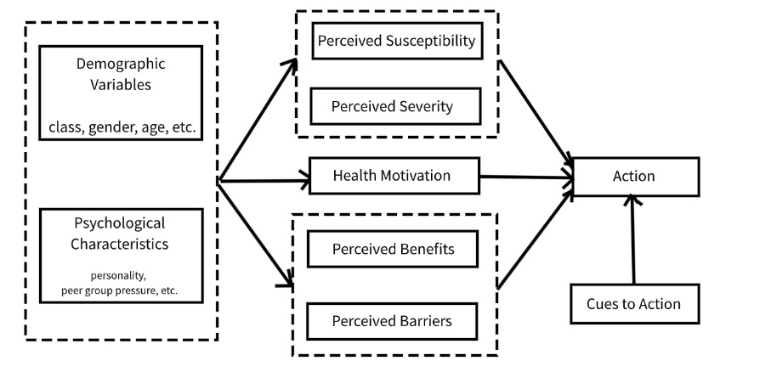
Figure 1. Health Belief Model Framework

